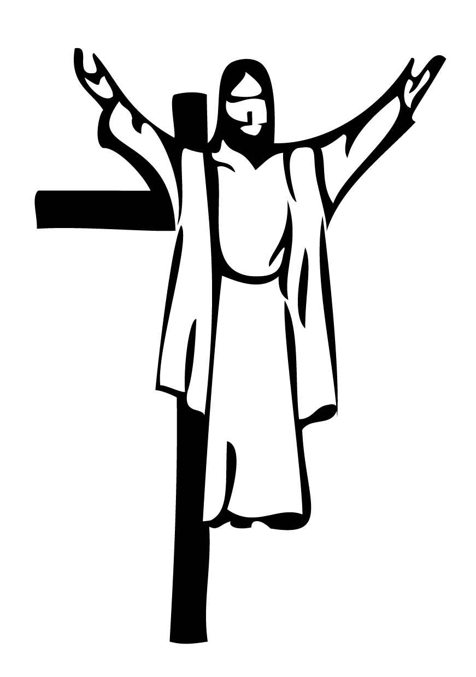
2020-2021
Religious Education Schedule
Grades k - 5
3175 Paulskirk Drive
Ellicott City, MD 21042

Church of the Resurrection  K-5 Religious Education  Sun A – Sundays, 3:30-5pm  Sun B – Sundays, 6:30-8pm | Church of the Resurrection  Middle School EDGE  Sundays, 3:30-5pm  (See separate schedule) | Resurrection  & St. Paul’s  High School Youth Ministry  Sundays, 6:15-8:15pm  (See separate schedule)

September
September 13 |  | Prayer Service  Compassion Camp
September 20 |  | Compassion Camp
September 27 |  | Compassion Camp
October
October 4 |  | No Class- Feast of St. Francis (optional)
October 11 |  | Compassion Camp
October 18 |  | Compassion Camp
October 25 |  | Walk for Homeless
November
November 1 |  | No Class- All Saints Day (optional)
November 8 |  | Class #1 God is calling us
November 15 |  | Class #2 Group 1
November 22 |  | Class #3 Advent (optional)
November 29 |  | No Class - Thanksgiving
December
December 6 |  | Class #4 Group 2
December 13 |  | Class #5 Group 3
December 20 |  | Class #6 Group 1
December 27 |  | No Class - Christmas
January
January 3 | Class #7 Group 2
January 10 | Class #8 Group 3
January 17 | No Class
January 24 | Class #9 Group 1
January 31 | Class #10 Group 2
February
February 7 | No Class
February 14 | No Class
February 21 | Class #11 Group 3
February 28 | Class #12 Group 1
March
March 7 | Class #13 Group 2
March 14 | Class #14  Resurrection Reconciliation
March 21 | Class #15 Group 3
March 28 | No Class - Palm Sunday
April
April 4 | No Class - Easter
April 11 | Class #16 Group 1
April 18 | Class #17 Group 2
April 25 | Class #18 Group 3

HOME PROGRAM K-8 [Parents teach their child(ren) at home]
Please see the Home Program’s full description on our website.

Those families registered in the Home Program are required to:
Attend the Parent Orientation Meeting on Thursday, September 24, 2020
Participate in one of the Parent Planning Sessions (at least one parent per assigned family) Thursday 6:30-8:00pm | Nov 5 | Dec 3 | Jan 14 | Feb 4 | Mar 4
Attend all five of the Family Gatherings  (at least one parent and all children)  6:30-8:00pm | Nov 19 | Dec 17 | Jan 28 | Feb 18 | Mar 18
Complete 25 Reflection Sheets and/or Chapter Review for each child
Complete 2 on-going social justice service projects (entire family participates)

